Easy spot

Program

<!DOCTYPE html>

<html lang="en">

<head>

  <meta charset="UTF-8" />

  <meta name="viewport" content="width=device-width, initial-scale=1.0" />

  <title>EazySpot</title>

  <style>

    body {

      margin: 0;

      font-family: 'Segoe UI', Tahoma, Geneva, Verdana, sans-serif;

      background: linear-gradient(to bottom right, #ebf8ff, #ffffff);

      color: #2d3748;

      padding: 1.5rem;

    }

    section {

      text-align: center;

      margin-bottom: 4rem;

    }

    button {

      background-color: #2563eb;

      color: white;

      padding: 0.75rem 1.5rem;

      border: none;

      border-radius: 0.5rem;

      font-size: 1rem;

      cursor: pointer;

    }

    .grid {

      display: grid;

      gap: 1.5rem;

      grid-template-columns: 1fr;

    }

    @media (min-width: 768px) {

      .grid {

        grid-template-columns: repeat(2, 1fr);

      }

    }

    .card {

      background: white;

      padding: 1.5rem;

      border-radius: 1rem;

      box-shadow: 0 4px 12px rgba(0, 0, 0, 0.1);

      text-align: left;

    }

    .card h2 {

      font-size: 1.25rem;

      margin-bottom: 0.5rem;

    }

    .card p {

      color: #4a5568;

    }

    .card-icon {

      width: 2rem;

      height: 2rem;

      margin-bottom: 1rem;

    }

  </style>

</head>

<body>

  <main id="app"></main>

  <script>

    document.addEventListener("DOMContentLoaded", () => {

      const app = document.getElementById("app");

      app.innerHTML = `

        <section>

          <h1 class="text-4xl font-bold">EazySpot: Your Smart Parking Assistant</h1>

          <p class="text-lg text-gray-600">Reinventing urban parking with AI, IoT, and real-time convenience.</p>

          <button>Get Started</button>

        </section>

        <section class="grid">

          <div class="card">

            <div class="card-icon" style="color: #2563eb;">📍</div>

            <h2>Real-Time Parking Navigation</h2>

            <p>Navigate to vacant spots easily with our AI-powered, real-time tracking system.</p>

          </div>

          <div class="card">

            <div class="card-icon" style="color: #16a34a;">⚡</div>

            <h2>EV Charging Integration</h2>

            <p>Support sustainable mobility with built-in EV charging stations at your parking spot.</p>

          </div>

          <div class="card">

            <div class="card-icon" style="color: #facc15;">🚗</div>

            <h2>On-Demand Car Wash</h2>

            <p>Book a car wash while you park—convenient, fast, and eco-friendly service.</p>

          </div>

          <div class="card">

            <div class="card-icon" style="color: #ef4444;">🛡️</div>

            <h2>Vehicle Security Alerts</h2>

            <p>Our sensors monitor and alert you in real-time for any unusual activity.</p>

          </div>

        </section>

        <section>

          <h2 class="text-3xl font-bold">Transforming Urban Life</h2>

          <p class="text-lg text-gray-700">EazySpot helps reduce traffic congestion and promote greener, smarter cities.</p>

          <button>Join the Future of Parking</button>

        </section>

      `;

    });

  </script>

</body>

</html>

Output

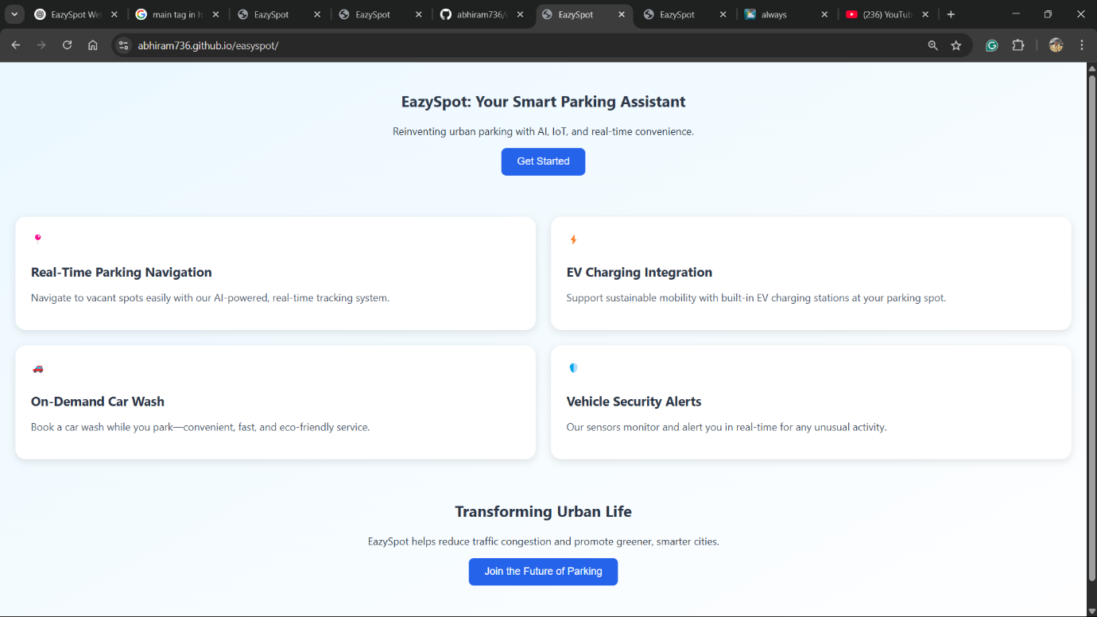

Repository

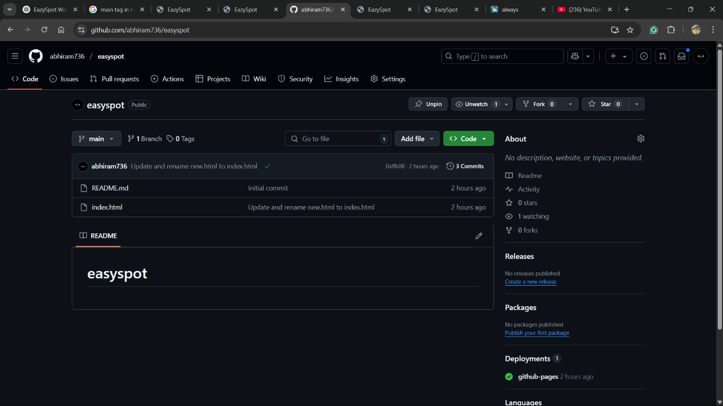

WORKDONE BY

Swathi

Sarah

Sana

Irin

Abhiram